**Machine Learning Engineer Nanodegree**

**Capstone Proposal**

Srinivasa Amirapu  
Nov 12th, 2018

**Proposal**

**Skin Cancer Detection with Transfer Learning on CNN models**

The goal of the problem is to design and develop an algorithm to diagnose skin lesion images as one of three different skin diseases (melanoma, nevus, or seborrheic keratosis). Objective of this project is to create a model to generate our own predictions which will classify malignant skin tumor from two types of benign lesions (nevi and seborrheic keratoses) with better accuracy.

***Personal Motivation****:*

I believe in “To err is human, to forgive is divine”. But to forgive an human error we need a better backup from a AI machine to validate our errors . In the current context we do not want to send sick patients home i.e., patients with malignant tumor should not be misclassified and sent home. So we need advanced predictive model for skin cancer detection which can help to better serve patients by offering them pre-screening before sending it to doctor who can confirm the results with further tests if needed. Since this problem is real world problem, I am motivated to build predictive model for skin cancer detection which can help in increasing survival rate of the patients.

***References****:*

1) https://challenge.kitware.com/#challenge/583f126bcad3a51cc66c8d9a

2) <https://www.udacity.com> (Dermatologist AI)

3) Dermatologist-level classification of skin cancer with deep neural networks by Andre Esteva, Brett Kuprel, Roberto A. Novoa, Justin Ko, Susan M. Swetter, Helen M. Blau & Sebastian Thrun

**Domain Background**

Skin cancer, the most common human malignancy, is primarily diagnosed visually, beginning with an initial clinical screening and followed potentially by dermoscopic analysis, a biopsy and histopathological examination. Automated classification of skin lesions using images is a challenging task owing to the fine-grained variability in the appearance of skin lesions. The CNN achieves performance on par with all tested experts across both tasks, demonstrating an artificial intelligence capable of classifying skin cancer with a level of competence comparable to dermatologists.

**Problem Statement**

The goal of the challenge is to develop image analysis tools to enable the automated diagnosis of melanoma from dermoscopic images. The main objective is to design an algorithm that can visually diagnose melanoma, the deadliest form of skin cancer. Our algorithm will distinguish this malignant skin tumor from two types of benign lesions (nevi and seborrheic keratoses). The data and objective are pulled from the 2017 ISIC Challenge on Skin Lesion Analysis Towards Melanoma Detection.

**Datasets and Inputs**

Datasets can be downloaded from the udacity repository by following below steps:-

1. Clone the repository and create a data/ folder to hold the dataset of skin images.

2. git clone https://github.com/udacity/dermatologist-ai.git

3. mkdir data; cd data

4. Create folders to hold the training, validation, and test images.

5. mkdir train; mkdir valid; mkdir test

6. Download and unzip the training data (5.3 GB).

7. Download and unzip the validation data (824.5 MB).

8. Download and unzip the test data (5.1 GB).

9. Place the training, validation, and test images in the data/ folder, at data/train/, data/valid/, and data/test/, respectively. Each folder should contain three sub-folders (melanoma/, nevus/, seborrheic\_keratosis/), each containing representative images from one of the three image classes.

**Solution Statement**

As deep learning techniques have been very effective in image classification over the years, in this project, transfer learning along with data augmentation will be used to train a convolutional neural network to classify images of skin lesions to their respective classes. Transfer learning refers to the process of using the weights from pre-trained networks on large dataset.

For training skin cancer detection model I will use weights from Pre-trained Keras models (VGG19,ResNet50,InceptionV3) and apply transfer learning which produces solution for this multi-class image classification problem. Finally I will select the model which yields better accuracy for predictions on test set.

**Benchmark Model**

**Algorithm Selection**

A wide class of models can be used for image classification with weights trained on ImageNet:

* Xception
* VGG16
* VGG19
* ResNet50
* InceptionV3
* InceptionResNetV2
* MobileNet
* DenseNet
* NASNet
* MobileNetV2

All of these architectures are compatible with all the backends (TensorFlow, Theano, and CNTK).

**Evaluation Metrics**

Inspired by the ISIC challenge, We can evaluate our algorithm based on one of the below 3 categories:-

#### Category 1: ROC AUC for Melanoma Classification

In the first category, we will gauge the ability of your CNN to distinguish between malignant melanoma and the benign skin lesions (nevus, seborrheic keratosis) by calculating the area under the receiver operating characteristic curve ([ROC AUC](http://scikit-learn.org/stable/modules/generated/sklearn.metrics.roc_auc_score.html)) corresponding to this binary classification task.

If you are unfamiliar with ROC (Receiver Operating Characteristic) curves and would like to learn more, you can check out the documentation in [scikit-learn](http://scikit-learn.org/stable/auto_examples/model_selection/plot_roc.html" \l "sphx-glr-auto-examples-model-selection-plot-roc-py" \t "_blank) or read [this Wikipedia article](https://en.wikipedia.org/wiki/Receiver_operating_characteristic).

The top scores (from the ISIC competition) in this category can be found in the image below.

[[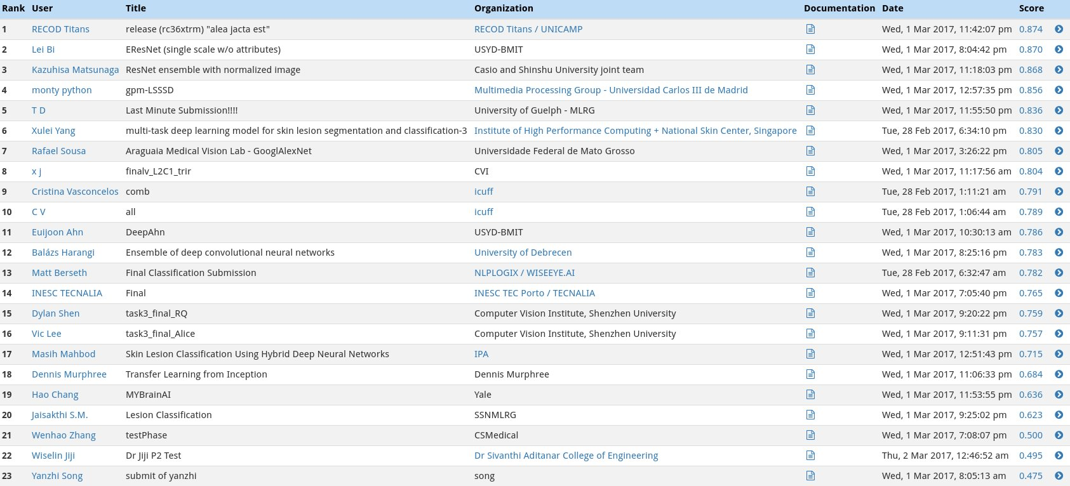](https://classroom.udacity.com/nanodegrees/nd009t/parts/0ac87c1d-350a-417b-93c8-392dbf9cb8c2/modules/f5e5f204-ae46-415c-bd9b-a160eecf044f/lessons/54e18898-2666-445d-ba5c-ecab62a61d00/concepts/6d13a6cb-b783-49e2-b67c-b65e53da0a67)](https://classroom.udacity.com/nanodegrees/nd009t/parts/0ac87c1d-350a-417b-93c8-392dbf9cb8c2/modules/f5e5f204-ae46-415c-bd9b-a160eecf044f/lessons/54e18898-2666-445d-ba5c-ecab62a61d00/concepts/6d13a6cb-b783-49e2-b67c-b65e53da0a67)

#### Category 2: ROC AUC for Melanocytic Classification

All of the skin lesions that we will examine are caused by abnormal growth of either [melanocytes](https://en.wikipedia.org/wiki/Melanocyte) or [keratinocytes](https://en.wikipedia.org/wiki/Keratinocyte), which are two different types of epidermal skin cells. Melanomas and nevi are derived from melanocytes, whereas seborrheic keratoses are derived from keratinocytes.

In the second category, we will test the ability of your CNN to distinuish between melanocytic and keratinocytic skin lesions by calculating the area under the receiver operating characteristic curve ([ROC AUC](http://scikit-learn.org/stable/modules/generated/sklearn.metrics.roc_auc_score.html)) corresponding to this binary classification task.

The top scores in this category (from the ISIC competition) can be found in the image below.

[[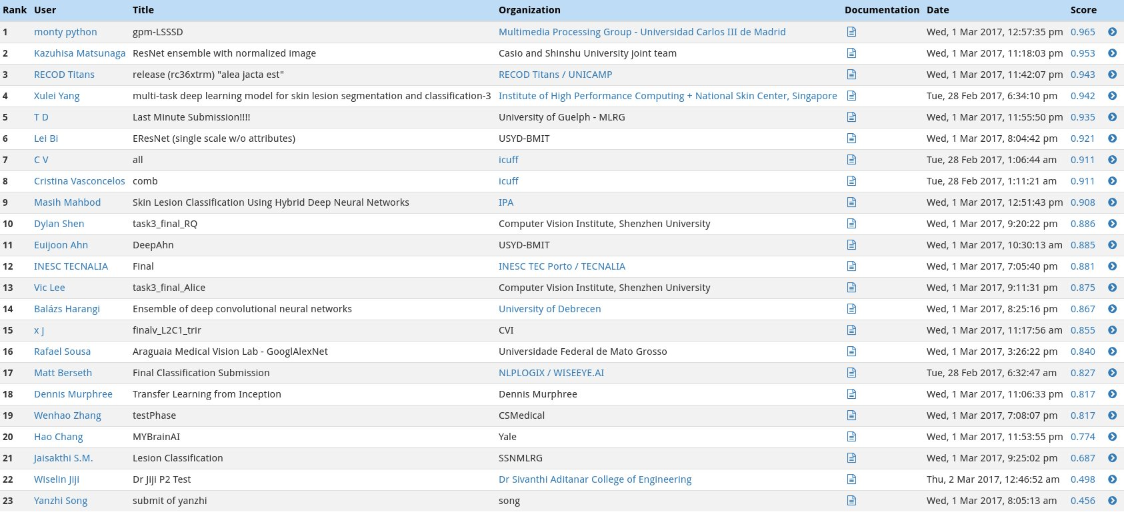](https://classroom.udacity.com/nanodegrees/nd009t/parts/0ac87c1d-350a-417b-93c8-392dbf9cb8c2/modules/f5e5f204-ae46-415c-bd9b-a160eecf044f/lessons/54e18898-2666-445d-ba5c-ecab62a61d00/concepts/6d13a6cb-b783-49e2-b67c-b65e53da0a67)](https://classroom.udacity.com/nanodegrees/nd009t/parts/0ac87c1d-350a-417b-93c8-392dbf9cb8c2/modules/f5e5f204-ae46-415c-bd9b-a160eecf044f/lessons/54e18898-2666-445d-ba5c-ecab62a61d00/concepts/6d13a6cb-b783-49e2-b67c-b65e53da0a67)

#### Category 3: Mean ROC AUC

In the third category, we will take the average of the ROC AUC values from the first two categories.

The top scores in this category (from the ISIC competition) can be found in the image below.

[[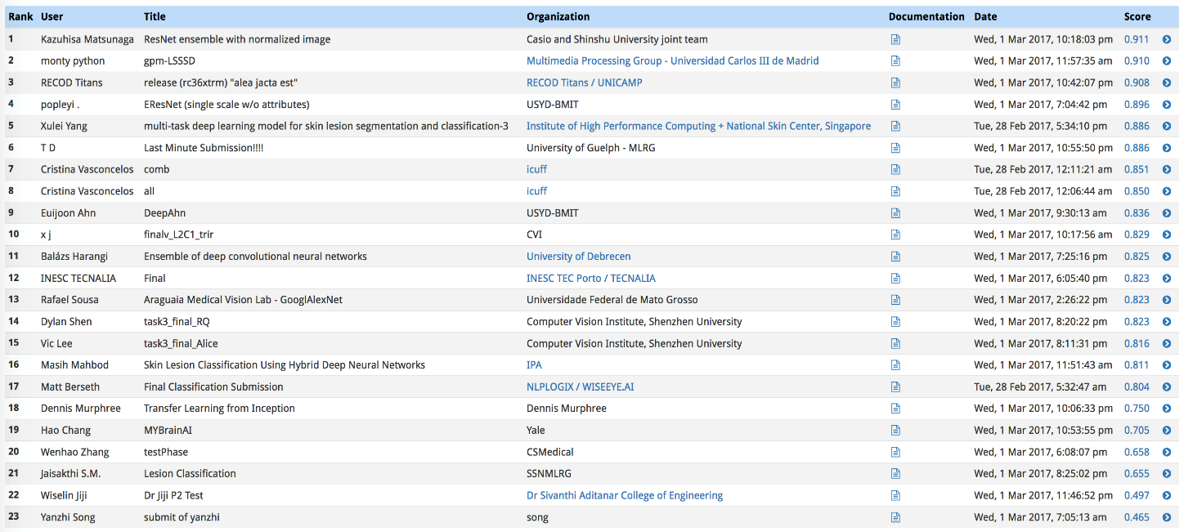](https://classroom.udacity.com/nanodegrees/nd009t/parts/0ac87c1d-350a-417b-93c8-392dbf9cb8c2/modules/f5e5f204-ae46-415c-bd9b-a160eecf044f/lessons/54e18898-2666-445d-ba5c-ecab62a61d00/concepts/6d13a6cb-b783-49e2-b67c-b65e53da0a67)](https://classroom.udacity.com/nanodegrees/nd009t/parts/0ac87c1d-350a-417b-93c8-392dbf9cb8c2/modules/f5e5f204-ae46-415c-bd9b-a160eecf044f/lessons/54e18898-2666-445d-ba5c-ecab62a61d00/concepts/6d13a6cb-b783-49e2-b67c-b65e53da0a67)

**Project Design**

**• Programming language** : Python 3.0

• **Libraries** : Keras, Tensorflow, Scikit-learn, Opencv

• **Workflow** :

o Training a small convolutional neural network from scratch for further comparison with transfer learning models.

o Extracting features from the images with the pretrained network and running a small fully connected network 3 output neurons on the last layer to get predictions.

o Fine tuning the pretrained network by choosing different optimizers and by training the network on this dataset from the convolutional layers instead of the dense layers as long as it's computationally inexpensive.

o Optionally, comparing the performance of multiple pretrained networks. However, as finetuning them is computationally expensive, different pretrained networks can be compared at the feature extraction stage instead of direct comparison.